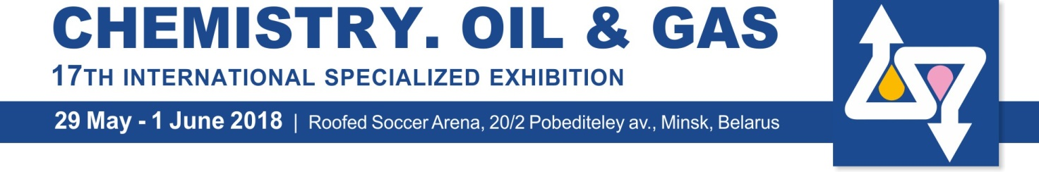
APPLICATION FORM №6 TRAVEL SERVICES Registration № _____

EXHIBITOR: _______________________________________ quantity of persons ______
№ | Type of service | Price without VAT, EURO | QTY | Cost, EURO
1. | Excursions:
1.1. | Cost of Minsk tour (lasting 2,5 - 4 hours) includes: (guide-interpreter for the group from 1 to 45 persons - from 45 Euros depending on language + cost of entrance tickets to museums and others + car rent depending on excursion time and quantity of persons, see p. 3.). Sightseeing tours and prices to be provided on request. | On request
1.2. | Cost of outside Minsk tour includes: (guide-interpreter for the group from 1 to 45 persons - from 45 Euros depending on language + cost of entrance tickets to museums and others + car rent depending on excursion time, quantity of persons, and distance from Minsk). Sightseeing tours and prices to be provided on request. | On request
2. | Hotels booking in Minsk | On request
3. | Transfers in Minsk:
3.1. | “Bus/Railway station – Hotel”» or “Hotel –Bus/Railway station” at day time (up to 4 persons) | 25
3.2. | “Bus/Railway station – Hotel”» or “Hotel –Bus/Railway station” at night time (22:00 – 8:00, up to 4 persons) | 30
3.3. | Additional service of guide-interpreter during the transfer in Minsk | 25
3.4. | “Bus/Railway station /Airport Minsk-1 –Hotel” or “Hotel – Bus/Railway station /Airport Minsk-1” (more than 4 persons) | On request
3.5. | “Airport Minsk-2 – Hotel” or “Hotel – Airport Minsk-2” at day time (up to 4 persons) | 40
3.6. | “Airport Minsk-2 – Hotel” or “Hotel – Airport Minsk-2” at night time (22:00 – 8:00, up to 4 persons) | 65
3.7. | “Airport Minsk-2 – Hotel” or “Hotel – Airport Minsk-2” (more than 4 persons) | On request
3.8. | Additional service of guide-interpreter during the transfer to the airport Minsk-2 | 30
Attention! The driver latency period is no longer than 1,5 hour. Quantity of passengers, time and service language to be agreed in advance.
4. | Car rent (with driver) for Minsk
4.1. | Car rent (up to 2 persons) for 1 hour | 20
4.2. | Minibus rent (from 2 to 4 persons) for 1 hour | 25
4.3. | Minibus rent (up to 7 persons) for 1 hour, but at least 2 hours | 25
4.4. | Minibus rent (up to 17 persons) for 1 hour, but at least 2 hours | 40
4.5. | Bus rent (up to 45 persons) for 1 hour, but at least 5 hours | On request
4.6. | Car rent outside Minsk | On request
5. | Services of interpreters and assistants
5.1. | English, German, French, Italian, Spanish, Polish for a group (4 hours / 8 hours) | 75 / 130
5.2. | Arabic, Chinese for a group (4 hours / 8 hours) | 90 / 160
5.3. | Japanese for a group (4 hours / 8 hours) | 130 / 250
5.4. | Other languages | On request
5.5. | Additional 1 hour (after 8 working hours), but no more than 4 hours – as in points: 5.1. / 5.2. / 5.3. (respectively) | 20 / 25 / 35
Attention! The cost of interpreter services does not include the cost of excursions and entrance tickets to museums, exhibitions, etc.
6. | Visa support:
6.1. | Official invitation for getting an individual visa in consular offices of the Republic of Belarus, 1 person (for Exhibitors only) | 5
6.2. | Visa support to get group (from 5 persons and more) tourist visas in consular offices of the Republic of Belarus (as per 1 person within the group) | 3
6.3. | Visa support to get tourist visa in the consular office of the airport Minsk-2 (50 km from Minsk) directly upon arrival (except groups more than 5 persons), in view of timely provision of all needed documents and delivery of originals to the airport no later than 5 days prior to arrival. | 15
6.4. | Courier delivery of documents originals to the consular office of the airport Minsk-2 | 40
Attention! When ordering a transfer from the airport Minsk-2, courier delivery of documents originals to the consular office is for free.
All prices are excluding VAT 20% |  | TOTAL:

Attention!
Cost improves on 50% if ordering 2 weeks before the event.

